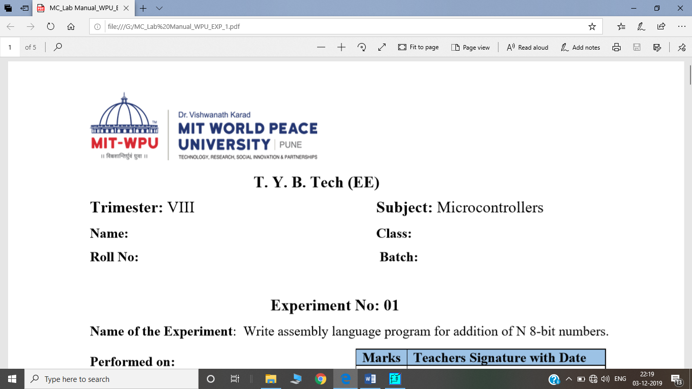

**Final Year BTech. (EE)**

**Semester: 5 Subject: AIML**

**Name: Shreerang Mhatre Class: TY   
Roll No.: 52 Batch: A3**

**Experiment No. 7**

**Aim:** **Implementation of Simple Genetic Algorithm**

**Objective:**

To get familiarize with Mathematical foundations for Genetic algorithm, operator.

To study the Applications of Genetic Algorithms

**Software Required:**

MATLAB

**Theory:**

Genetic algorithm is a search technique used in computing to find true or approximate solutions to approximate solutions to optimization & search problems.

Genetic algorithms are inspired by Darwin's theory about evolution. Solution to a problem solved by genetic algorithms is evolved.

Algorithm is started with a set of solutions (represented by chromosomes) called population. Solutions from one population are taken and used to form a new population.

|  |  |  |  |  |  |
| --- | --- | --- | --- | --- | --- |
| **AMP/WPU/AIML/2022** | | |  | **Expt. 9- 1** | |
|  |  |  |  |  |  |
|  |  |  | **WWW.MITWPU.COM** | | |



This is motivated by a hope, that the new population will be better than the old one. Solutions which are selected to form new solutions (offspring) are selected according to their fitness - the more suitable they are the more chances they have to reproduce. This is repeated until some condition (for example number of populations or improvement of the best solution) is satisfied

**Outline of the Basic Genetic Algorithm**

1. **[Start]** Generate random population of *n* chromosomes (suitable solutions for the problem)

2. **[Fitness]** Evaluate the fitness *f(x)* of each chromosome *x* in the population

3. **[New population]** Create a new population by repeating following steps until the new population is complete

1. **[Selection]** Select two parent chromosomes from a population according to their fitness (the better fitness, the bigger chance to be selected)

2. **[Crossover]** With a crossover probability cross over the parents to form a new offspring (children). If no crossover was performed, offspring is an exact copy of parents.

3. **[Mutation]** With a mutation probability mutate new offspring at each locus (position in chromosome).

4. [**Accepting**] Place new offspring in a new population

5. [**Replace**] Use new generated population for a further run of algorithm

6. [**Test**] If the end condition is satisfied, stop, and return the best solution in current population

7. [**Loop**] Go to step 2

|  |  |  |  |  |  |
| --- | --- | --- | --- | --- | --- |
| **AMP/WPU/AIML/2022** | | |  | **Expt. 9- 2** | |
|  |  |  |  |  |  |
|  |  |  | **WWW.MITWPU.COM** | | |



**Flowchart**

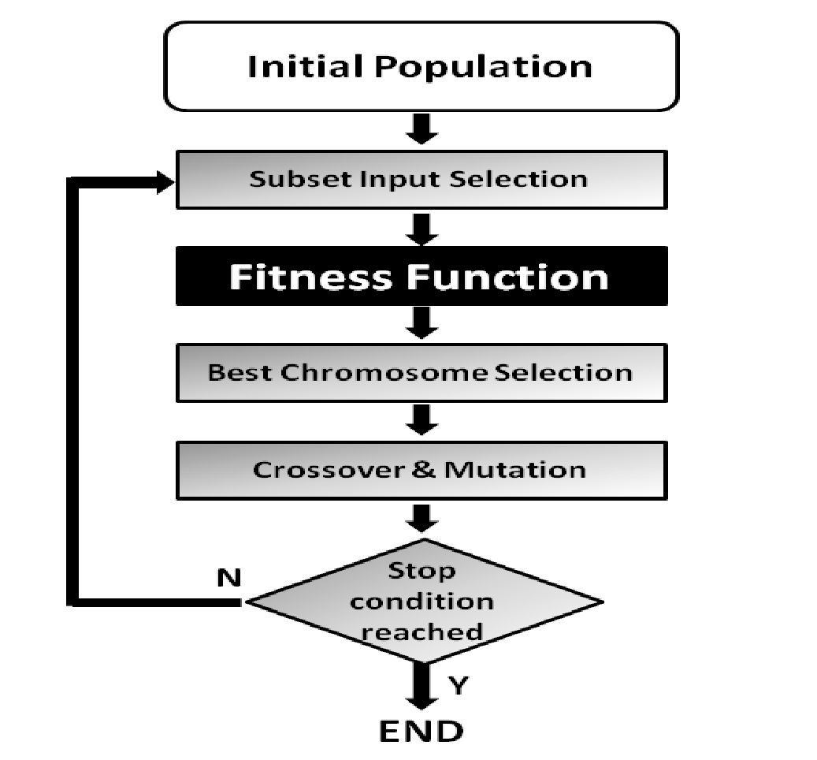

**Algorithm:**

* **Firstly, we defined our initial population as our countrymen.**
* **We defined a function to classify whether is a person is good or bad.**
* **Then we selected good people for mating to produce their off-springs.**
* **And finally, these off-springs replace the bad people from the population and this process repeats.**
* **This is how genetic algorithm actually works, which basically tries to mimic the human evolution to some extent.**
* **it is an optimization technique, which tries to find out such values of input so that we get the best output values or results.**

**The working of a genetic algorithm is also derived from biology**

|  |  |  |  |  |  |
| --- | --- | --- | --- | --- | --- |
| **AMP/WPU/AIML/2022** | | |  | **Expt. 9- 3** | |
|  |  |  |  |  |  |
|  |  |  | **WWW.MITWPU.COM** | | |



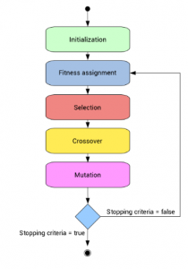

**Pseudo code for GA:**

* **START**
* **Generate the initial population**
* **Compute fitness**
* **REPEAT**
* **Selection**
* **Crossover**
* **Mutation**
* **Compute fitness**
* **UNTIL population has converged**
* **STOP**

|  |  |  |  |  |  |  |
| --- | --- | --- | --- | --- | --- | --- |
| **AMP/WPU/AIML/2022** | | |  | **Expt. 9- 4** | | |
|  |  |  | | |  |
|  | **WWW.MITWPU.COM** | | | | |



**Conclusion:**

**Post Lab Questions:**

1. Name some of the existing search methods.
2. What are the operators involved in a simple genetic algorithm?
3. What is reproduction?
4. What is crossover?
5. Write the code for GA and implement it using Python.

|  |  |  |  |  |  |  |
| --- | --- | --- | --- | --- | --- | --- |
| **AMP/WPU/AIML/2022** | | |  | **Expt. 9- 5** | | |
|  |  |  | | |  |
|  | **WWW.MITWPU.COM** | | | | |

CODE:

